**UNIVERSITI MALAYSIA TERENGGANU**

**CSM3103 FRONT-END PROGRAMMING (K1)**

**BACHELOR OF COMPUTER SCIENCE (MOBILE COMPUTING) WITH HONORS**

**LAB 1 –BASIC OF BOOTSTRAPS**

**SEMESTER 4 2024/2025**

**Prepared for:**

DR. RABIEIL B MAMAT

**Prepared by:**

NUR ARINA BINTI ABDUL MALEK (S65361)

CSM3101/CSM3503 Lab 1 – Basic of Bootstraps

Task 1 – Your First bootstrap’s pages Using Content Delivery Network (CDN)

1. Download https://skimtech.my/frend/boilerplate.zip and extract zip file
   1. Modify the existing index.html

!DOCTYPE html>

<html lang="en">

<head>

<title>Bootstrap Tutorial Sample Page</title>

<meta charset="utf-8">

<meta name="viewport" content="width=device-width, initial-scale=1">

</head>

<body>

<div class=”container”>

<div class=”row”>

<h1>Hello Bootstrap</h1>

</div>

</div>

</body>

</html>

1. Open your newly created index.html in the browser
2. Evaluate the output

1. Add the following slightly before </body> section of your index.htm

<script src="https://code.jquery.com/jquery-3.5.1.min.js" integrity="sha256-9/aliU8dGd2tb6OSsuzixeV4y/faTqgFtohetphbbj0=" crossorigin="anonymous"></script>

<script [src="https://cdn.jsdelivr.net/npm/bootstrap@4.5.3/dist/js/bootstrap](https://cdn.jsdelivr.net/npm/bootstrap%404.5.3/dist/js/bootstrap)

.min.js" integrity="sha384- w1Q4orYjBQndcko6MimVbzY0tgp4pWB4lZ7lr30WKz0vr/aWKhXdBNmNb5D92v7s" crossorigin="anonymous"></script>

1. Add the following to Save and open your file in the browser
2. Evaluate your result and compare the output with step (3)

1. Give your opinion about the differences
2. If have any error, explain why and how you resolve the error.

Task 2 – Your first bootstrap’s with local link

1. Download <https://skimtech.my/frend/boilerplate.zip> and extract zip file
2. Modify index.html
   1. Add the following into the head section

<link rel="stylesheet" href="css/bootstrap.min.css">

* 1. Add the following before </body> in the index file.

<script src="js/jquery-3.6.4.min.js"></script>

<script src="js/bootstrap.min.js"></script>

#Noted that the arrangement is important where jQuery is first and bootstrap is second (because dependency of bootstrap on jQuery)

1. Save your file and open in browser Evaluate your result and compare with Task1(6)

1. What is your conclusion?

Task 3 – Example of using Bootstrap

1. Copy task 2 folder into new folder names Task3
2. Modify index.html
3. Add the navigation bar (Menu)
   1. Add the following code slightly after <body>

<nav class="navbar navbar-expand-md">

<a class="navbar-brand" href="#">CSM3103</a>

<button class="navbar-toggler navbar-dark" type="button" data-toggle="collapse" data-target="#main-navigation">

<span class="navbar-toggler-icon"></span>

</button>

<div class="collapse navbar-collapse" id="main- navigation">

<ul class="navbar-nav">

<li class="nav-item">

<a class="nav-link" href="#">Home</a>

</li>

<li class="nav-item">

<a class="nav-link" href="#">About</a>

</li>

<li class="nav-item">

<a class="nav-link" href="#">Contact</a>

</li>

</ul>

</div>

</nav>

* 1. Save and evaluates the result

* 1. Some notes:

navbar-expand-md — This denotes at which point the navigation bar expands from vertical or hamburger icon to a full-size horizontal bar. In this case, we have set it to medium screens, which, in Bootstrap, is anything greater than 768px.

navbar-brand — This is used for your website branding. You can also include a logo image file here.

navbar-toggler — Denotes the toggle button for the collapsed menu. The piece data-toggle="collapse" defines that this will turn to a hamburger menu, not to drop-down, which is the other option. It’s important that you define a data-target with a CSS id (defined by the #) and wrap a <div> with the same name around the actual navbar element.

navbar-toggler-icon — As you can probably guess, this creates the icon users click on to open the menu on smaller screens.

navbar-nav — The class for the <ul> list element that holds the menu items. The latter are denoted with nav-item and nav-link.

1. Remove all <div>’s which are in between </nav> and <script>
2. Adding new css file
   1. Create a new file using your editor names your file as main.css and save in the css folder of current task
   2. Put these codes into the main.css

body {

padding: 0;

margin: 0; background: #f2f6e9;

}

.navbar {

background:#6ab446;

}

.nav-link,

.navbar-brand { color: #fff; cursor: pointer;

}

.nav-link {

margin-right: 1em !important;

}

.nav-link:hover { color: #000;

}

.navbar-collapse {

justify-content: flex-end;

}

* 1. Add new link refer to main.css in the head section after bootstrap.css link
  2. Save your file and open your file using browser
  3. Now our page is much better

1. Set the background image for header
   1. Download <https://skimtech.my/frend/header-background.jpg>
   2. Store into images folder of your project (create one if none)
   3. Add the following code into main.css

.header {

background-image: url(‘../images/header-background.jpg’);

background-size: cover; background-position: center; position: relative;

}

* 1. Create a new file using your editor
  2. Save your file as main.js inside the js folder
  3. Put the following code inside main.js

$(document).ready(function(){

$(‘.header’).height($(window).height());

})

* 1. Add a new link to main.js in your index.html file after bootstrap.js link
  2. Add header below </nav>

<header class=”header”>

</header>

* 1. Evaluate the results

1. Add some description on header
   1. Add the <div> and text as follow inside <header></header>

<div>

<h1>Welcome to CSM3103</h1>

<p>This course introduces students to mobile application development. It will cover the topic like the front-end development, server and database connectivity and event handling. Some technology such as Javascript, JQuery, JSON, AJAX and Resful will be discussed as well. Hands on programming and group project given to strengthen students programming skills.</p>

</div>

* 1. Save and see the output on the browser

* 1. What do you think about the result?

1. Modify the header description with some CSS
   1. Add the following class into your main.css

.description { left: 50%;

position: absolute; top: 45%;

transform: translate(-50%, -55%); text-align: center;

}

.description h1 { color: #6ab446;

}

.description p { color: #fff;

font-size: 1.3rem; line-height: 1.5;

}

* 1. Add class=”description” inside the <div> above the description
  2. Save and evaluate the output

###########

1. Put some overlay on image
   1. Add the following class definition into the main.css

.overlay {

position: absolute; min-height: 100%;

min-width: 100%;

left: 0;

top: 0;

background: rgba(0, 0, 0, 0.6);

}

* 1. Save your main.css
  2. Add the following <div> into the index.html, before the <div> for the description

<div class=”overlay”></div>

* 1. Save your file and evaluate the result
  2. Now, the light of image is dimmer, and the description text is more clear

1. Add the button to description
   1. At the end of the descriptions text after </p>, add the button

<button class=”btn btn-outline-secondary btn-lg”> Tell Me More </Button>

* 1. Test your result
  2. Add the following class definition into the main.css,

.description button {

border: 1px solid #6ab446; background: #6ab446; border-radius: 0;

color: #fff;

}

.description button:hover { border: 1px solid #fff; background: #fff; color: #000;

}

* 1. Test your result

1. Prepare the main content
   1. Download <https://skimtech.my/frend/images.zip> and extract into your project folder
   2. Setup a three columns section by the following html code after </header>

<div class="container">

<div class="row">

<div class="col-lg-4 col-md-4 col-sm-6">

<h3 >Our Skill</h3>

<img src="images/programmer.jpg" class="img-fluid">

<p>This is an area where mobile apps prove to be highly beneficial. Highly interactive and scalable mobile apps offer a robust communication platform for both entrepreneurs and their employees. You will develop and fine-tune your managerial skills, thus making it big in your respective professional arena.</p>

</div>

<div class="col-lg-4 col-md-4 col-sm-6">

<h3>Interaction</h3>

<img src="images/project.jpg" class="img-fluid">

<p>Today every business relies on the most efficient thought leaders and policy planners. If you wish to enter into that league, there’s no other way than to develop these skills. Highly interactive enterprise applications will help develop these communication and leadership skills.</p>

</div>

<div class="col-lg-4 col-md-4 col-sm-6">

</div>

</div>

Notes:

class=”row” – required when creating a column to act as a container for the grif

class “col-lg-4” - on large screen , the column size is 4 columns of 12 (3 Columns)

class “col-md-4 – on medium screen , the column is 4 columns out of 12 (3 Columns)

class “col-sm-12” – on small screen, the column size is 12 columns out of 12 (1 Column)

Based on above definition On large screen – 3 columns

On medium screen – 3 columns

Small screen – I column with 3 rows

* 1. Evaluate your result

* 1. Add the following style into the main.css

.features {

margin: 4em auto; padding: 1em; position: relative;

}

.feature-title {

color: #333;

font-size: 1.3rem;

font-weight: 700; margin-bottom: 20px;

text-transform: uppercase;

}

.features img {

-webkit-box-shadow: 1px 1px 4px rgba(0, 0, 0,0.4);

-moz-box-shadow: 1px 1px 4px rgba(0, 0, 0, 0.4);

box-shadow: 1px 1px 4px rgba(0, 0, 0, 0.4); margin-bottom: 16px;

}

* 1. Add feature-titles class to each of image title
  2. Evaluate your result.

* 1. Add a contact form inside the last column by the following code

<h3>Get in Touch!</h3>

<div class="form-group">

<input type="text" class="form-control" placeholder="Name"

name="">

</div>

<div class="form-group">

<input type="email" class="form-control" placeholder="Email

Address" name="email">

</div>

<div class="form-group">

<textarea class="form-control" rows="4"></textarea>

</div>

<input type="submit" class="btn btn-secondary btn-block"

value="Send" name="">

Notes:

form-group – used to wrap around form fields for formatting

form-control – denotes form fields such as inputs, text areas and etc.

* 1. Add some css for your form by the following css code inside main.css

.features .form-control,

.features input {

border-radius: 0;

}

.features .btn {

background-color: #589b37; border: 1px solid #589b37; color: #fff;

margin-top: 20px;

}

.features .btn:hover {

background-color: #333; border: 1px solid #333;

}

* 1. Update container <div> as follows

<div class="container features">

* 1. Evaluate your results

1. Adding a New Container
   1. Put the following code after the last container block

<div class="container ">

<div class="row">

<!—your will put here later (AA)-->

</div>

</div>

* 1. Put the following code at AA line inside the container in 12.

<div class="card col-lg-3 col-md-3 col-sm-4 text-center">

<img class="card-img-top rounded-circle" src="images/team-image-

1.png" alt="Card image">

<div class="card-body">

<h4 class="card-title">Jane Doe</h4>

<p class="card-text">Job Description</p>

</div>

</div>

Notes:

* 1. Save your file and evaluates the output

* 1. Change the background of the new container
     1. Add to main.css

.background {

background: #dedec8; padding: 4em 0;

}

* + 1. Add new <div class=”background”> </div> surrounding <div> in (a)

above

* + 1. Test and evaluate your results.

* 1. Add 8 more cards into your index.html
  2. add more style to current container. Put following css code into the main.css

.team {

color: #5e5e55; padding: 0 180px;

}

.team .card-columns {

-webkit-column-count: 4;

-moz-column-count: 4;

column-count: 4;

}

.team .card {

background:none; border: none;

}

.team .card-title {

font-size: 1.3rem; margin-bottom: 0;

text-transform: uppercase;

}

* 1. update <div class=”container> to <div class=”container team”>
  2. evaluate your result

1. Preparing the footer
   1. Add the following footer for your page

<footer class="page-footer">

<div class="container">

<div class="row">

<div class="col-lg-8 col-md-8 col-sm-12">

<h6 class="text-uppercase font-weight-bold">Additional Information</h6>

<p>For more information you can visit our office as the given address</p>

<p>Or, you can also make a phone call to the given phone number.</p>

</div>

<div class="col-lg-4 col-md-4 col-sm-12">

<h6 class="text-uppercase font-weight-bold">Contact</h6>

<p>1640 Riverside Drive, Hill Valley, California

<br/[>info@csm](mailto:info@csm3103.com)3[103.com](mailto:info@csm3103.com)

<br/>+ 01 234 567 88

<br/>+ 01 234 567 89</p>

</div>

</div>

<div class="footer-copyright text-center">© 2023 Copyright: csm3103.com</div>

</footer>

* 1. Test and evaluate the result

* 1. Write a footer style in main.js and update the <footer class=”page-footer”>

.page-footer {

background-color: #222; color: #ccc;

padding: 60px 0 30px;

}

.footer-copyright {

color: #666;

padding: 40px 0;

}

1. Mobille-first
   1. Add the the following media query code

@media (max-width: 991.98px) {

.team {

padding: 0 15px;

}

}

@media (max-width: 575.98px) {

.description {

left: 0;

padding: 0 15px; position: absolute; top: 10%; transform: none; text-align: center;

}

.description h1 {

font-size: 2em;

}

.description p {

font-size: 1.2rem;

}

.features {

margin: 0;

}

.team {

max-width: 60%;

}

* 1. Test and evaluate your result

Task 4:

1. Download <https://skimtech.my/frend/Task4.zip> and extract to default folder Task4
2. Link the `css/styles.css` file in the index.html `<head>` section. All required styles will be written in here later.
3. Add bootstrap link using CDN. Use the ([https://getbootstrap.com/docs/4.5/getting-started/introduction/#quick-](https://getbootstrap.com/docs/4.5/getting-started/introduction/#quick-start) [start](https://getbootstrap.com/docs/4.5/getting-started/introduction/#quick-start))
4. Apply the bootstrap grid classes (<https://getbootstrap.com/docs/4.5/layout/grid/>)
   1. The 4 cookie products should appear side by side in one row on large screens
   2. 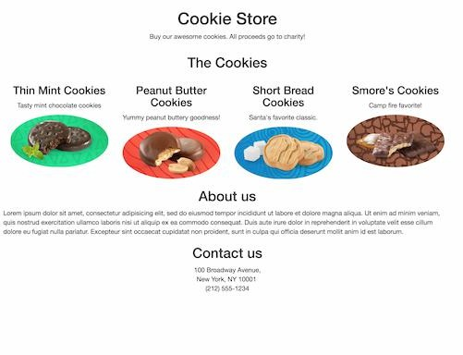The 4 cookies should appear one per row on medium and smaller screens
5. Apply styling to make the page responsive as follows:
   1. 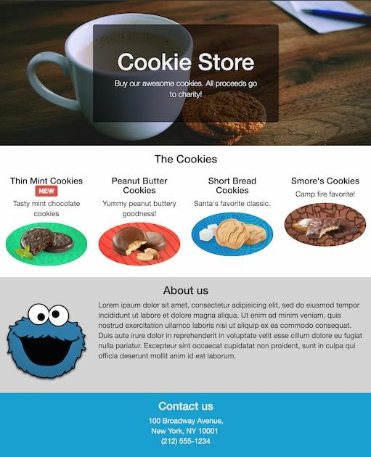On large screen
   2. 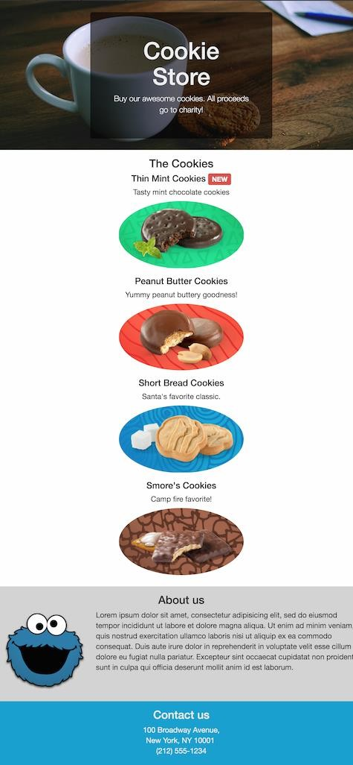On medium and smaller screen

Submission

* + 1. Upload Task 3 and Task 4 as Lab1 into GitHub
    2. In Microsoft Word
       1. Share a GitHub link for Lab1
       2. Print-screen the output for each task
       3. Upload word doc into epembelajaran